The Clarinet and Saxophone Society of Victoria is pleased to present
2018 Professional Development Day for
Clarinet and Saxophone Teachers
With Paul Jenkins
Saturday, April 28, 2018 2-5 pm
Ashburton Community Centre, 160 High St., Ashburton
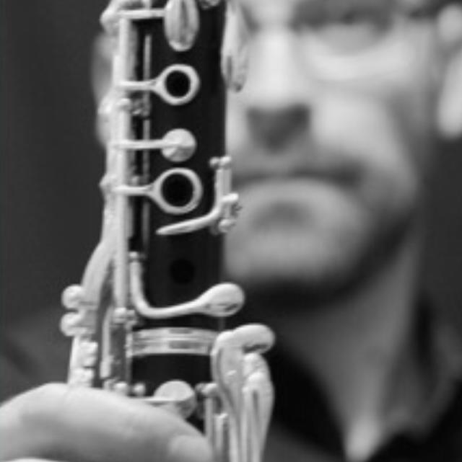
1:45 pm-Registration
2:00 pm-The different ways to approach playing and teaching clarinet, saxophone and flute. Bring your non major instrument for a more hands on workshop.
3:30 pm- Afternoon Tea
3:45 pm-Ensemble repertoire for mixed groups and also for like instruments, and other books not widely known (bring your music to share). Paul will give us some thoughts on unison playing, then simple two part harmony. He will also talk about scaffolding for ensembles.
4:40 pm-Sturt Brownley from Daddario reeds showcasing the new saxophone mouthpiece from Daddario
Paul Jenkins is a graduate of the Victorian College of the Arts and holds a Masters in Music and Grad. Dip. Ed. from Monash University. He studied clarinet primarily with Kate Stockwin and Ian Morgan but also performed in master classes with Robert Schubert, David Griffiths and Paul Champion. He has performed with many ensembles including Melbourne Youth Orchestra, Melbourne Opera Orchestra, Grainger Wind Symphony and many ‘scratch orchestras.’ He is the founder and current VP of Peninsula Chamber Musicians, Inc.
Paul also regularly performs as a woodwind multi-instrumentalist for musical theatre and has performed on flute, oboe and bassoon in community orchestras. He enjoys studying the repertoire and nuances of the woodwind family and has developed a large bag of tricks over his 20 years of teaching.
___________________________________________________________________________
Clasax PD Day Registration Form 2018
Name______________________________________________________________________
Address____________________________________________________________________
Phone______________________ Email___________________________________________
Cost-$35 for Clasax members $45 for non-members
Payments Options (please circle one):
Cheque or moneyorder (send with registration form with cheque made out to Clarinet and Saxophone Society of Victoria, Inc), PO Box 380 Burwood, Vic. 3125. Clasax ABN 82 556 321143
Bank Transfer: CBA BSB 063001 ACT 00905518-please put your name as the reference
Paypal: visit www. Clasax.org
Send registration form to joann_griffiths@optusnet.com.au and pay via bank transfer. Any queries to JoAnn Griffiths 0407 247 410 Registration due by April 16

