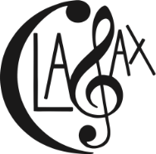
The Clarinet and Saxophone Society of Victoria, Inc is pleased to present Clarinet Ensemble Day
Sat August 4, 2018
St. Thomas’ Anglican Church
44 Station Street, Burwood
9:30am-4:30 (concert at 4 pm)
With Professor Friedrich K. Pfatschbacher as our special guest conductor
Bring your clarinet, music stand, lunch and water bottle. Morning tea provided.
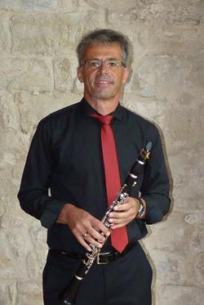
9:15-Registration
9:30-Rehearsal
11:00-Morning Tea
11:30-Rehearsal
12:45-Lunch
1:30-Rehearsal
3:30-Finish up, prepare for concert
4:00 Concert
4:30-Finish for the Day
Our special guest for the day is Professor Friedrich Pfatschbacher from Austria who is a clarinettist with specific interests in performance, education, lecturing and clarinet choir workshops. He is an active performer and involved with several professional organisations and ensembles. He has also written a book Clarinet Choirs which is of great interest.
Name______________________________________________________________________________
Email______________________________________________________________________________
Phone number_____________________________________-
What type of clarinet do you play? Bb, Eb, alto, bass, contrabass
Cost-$30 for Clasax members $35 for non members
Payment Options-Cheques (send with registration form made out to the Clarinet and Saxophone Society of Victoria, Inc), PO Box 380, Burwood, Vic. 3125
Direct Debit-CBA BSB-63001 ACT-00905518-please put your name as the reference and send registration to joann_griffiths@optusnet.com.au
Paypal:visit www.clasax.org
Queries-JoAnn Griffiths 0407 247 410 ABN 82 556 321143
Registration forms can be sent via email to joann_griffiths@optusnet.com.au . Any queries to JoAnn Griffiths 0407 247 410 ABN 82 556 32114

